# KiCAD Schematic module

# Scope

This document should be a general guide for common setup of KiCAD schematic tool Eeschema supporting

PCB design process.

# General settings

For a consistent design make sure all settings below are set up before starting to design.

Please navigate to:

**Preferences→Schematic Editor Options→ General Options**

| Setting | Selection |
| --- | --- |
| Measurement units: | mm |
| Grid Size: | 50 mil |
| Default bus width: | 20 mil |
| Default line width: | 14 mil |
| Default text size: | 79 mil |
| Repeat draw item horizontal displacement | 0 |
| Repeat draw item vertical displacement | 100 |
| Repeat label increment: | 1 |
| Auto save time interval: | any |
| Part id notation: | A |

The following settings adds custom fields to the schematic symbols which are used in SHL

for ordering process.

Please navigate to:

**Preferences→Schematic Editor Options→Template Field Names**

| Field name | Default value | Visible |
| --- | --- | --- |
| MFN | (empty) | Hidden |
| MFP | (empty) | Hidden |
| Description | (empty) | Hidden |

MFN: Manufacturer name of the component.

MFP: Manufacturer part number.

Description: Brief description about key properties of the component.

# Drawing field

When a schematic design file is released the drawing field need to be filled out to clearly identify the document.

The revision field can be filled out by a property window which is integrated in Eeschema.

Navigate to: **File→ Page settings**

Title Block Parameters:

| Kicad page settings | Drawing Frame | Note |
| --- | --- | --- |
| Issue Date | Revision Date | The date when the last change  where made. |
| Revision | REVISION | Specified in:  2.4 [Document Controls](http://confluence.shl-internal.com/display/ESDQMS/Document+Controls) |
| Title |  | Any title for the entire project. |
| Company | Not used |  |
| Comment1 | Name | Name of the engineer which  release the schematic. |
| Comment2 | MATERIAL | It can be specified which PCB  base material is used. |
| Comment3 | DRAWING | Document numbering according to  2.3.4 [Document Controls](http://confluence.shl-internal.com/display/ESDQMS/Document+Controls) must be used. |
| Comment4 | Department | Department or business division can  be added. |
| Page layout description  file | Template | This is the path of the drawing template. |
|  | Drawing Frame | Note |
|  | Reviewer: | After a review by a peer name should be recorded  by placing a graphical text manually in the drawing field. |
|  | DATE: | After a review by a peer date should be recorded  by placing a graphical text manually in the drawing field. |

# Generate output

In Eeschema we will create several types of output files before design freeze.

* Schematic plot for project documentation
* Net List for interfacing to the PCB layout modle
* Bill of Material for purchase process

## Schematic

For schematic drawings PDF or DXF file format is quite common to publish.

Navigate to: File → Plot → Plot

Chose your desired format and Plot all pages.

## Netlist

The netlist need to be created for PCBnew. It will be imported later for layout.

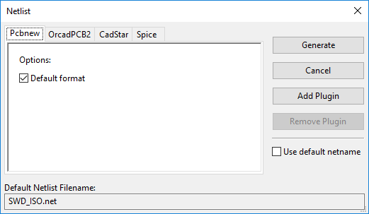

## Bill of material

To create a BOM with components grouped by same value a Plugin need to be added first.

The Plugin is called "bom2groupedCsv" and need to be copied into a local folder.

Click "**Add Plugin**" and chose the file bom2groupedCsv.xsl.

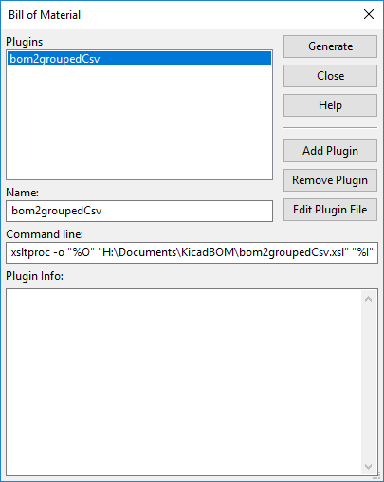

The BOM list is generated after clicking "**Generate**" and is saved into the project folder as "CSV" file.

# References

* Eeschema manual